Coffee PO - Final Project Report



# Project Title and Team Members

**Project Title:** Coffee PO - Coffee Shop Website

**Team Name:** Master PO

**Group:** SE-2436

**Team Members:**

1. Saqyp Dias
2. Qazybai Ali
3. Izimbetov Nurzhan
4. Nurasyl Asan
5. Altyngazimov Alinur

**Links:**

 **GitHub Repository:** [GitHub](https://github.com/aaituu/BalgynWEB/WEB-finall)

 **Live Website:** [Coffe PO](https://aaituu.github.io/BalgynWEB/WEB-finall/)



# Project Goal and Description

## Project Overview

Coffee PO is a modern, fully responsive multi-page website for a coffee shop located in Astana, Kazakhstan. The project aims to provide an engaging online presence for the coffee shop, allowing customers to explore the menu, view the gallery, contact the business, and manage their user accounts.

## Main Goal

To create a professional, user-friendly website that demonstrates advanced web development skills including responsive design, user authentication, interactive features, and accessibility compliance.

## Target Audience

 Coffee lovers in Astana, Kazakhstan  Young professionals aged 18-35

 Students looking for a comfortable study space  Anyone interested in quality coffee and pastries

## Key Features

1. **Responsive Design** - Works seamlessly on mobile, tablet, and desktop
2. **User Authentication** - Sign up, log in, and personal profile management
3. **Dark/Light Mode** - Toggle between themes with localStorage persistence
4. **Interactive Gallery** - Showcase coffee shop atmosphere and products
5. **Dynamic Menu** - Display coffee and food items with search functionality
6. **Contact System** - Functional contact form with validation and feedback history
7. **jQuery Enhancements** - Search, animations, lazy loading, and more
8. **Accessibility** - WCAG AA compliant with keyboard navigation support

## Technology Stack

 **HTML5** - Semantic markup structure

 **CSS3** - Custom styling with animations and transitions

 **JavaScript (ES6)** - Interactive functionality and form validation

 **Bootstrap 5.3.2** - Responsive grid and components

 **jQuery 3.7.1** - DOM manipulation and enhanced UX features

 **LocalStorage API** - User authentication and theme persistence

 **Google Fonts** - Typography (Montserrat)



# Work Division

## Frontend Developer & Design Lead

**Responsibilities:**

 Created HTML structure for all pages (index.html, gallery.html, menu.html)  Designed responsive layout using Bootstrap grid system

 Implemented CSS styling and color schemes

 Created and optimized all images and graphics  Ensured visual consistency across pages

**Files Worked On:**

 index.html

 gallery.html  menu.html

 style.css (design sections)

 /img/ folder



## JavaScript Developer & Authentication System

**Responsibilities:**

 Developed user authentication system (signup, login, profile)  Implemented form validation with regex patterns

 Created localStorage management for user data  Built profile page with feedback history

 Developed dynamic navigation based on auth status

**Files Worked On:**

 auth.js

 signup.html  login.html

 profile.html

 Form validation logic

**Time Contribution:** ~30 hours



## jQuery Features & Interactive Elements

**Responsibilities:**

 Implemented jQuery search functionality

 Created animated counters and scroll progress bar  Developed lazy loading for images

 Added copy-to-clipboard features  Built notification system

 Enhanced UX with smooth animations

**Files Worked On:**

 jquery-features.js

 Interactive components in all pages  Animation and transition effects

**Time Contribution:** ~25 hours



## Integration, Testing & Deployment

**Responsibilities:**

 Integrated all components and ensured consistency  Implemented dark/light mode with localStorage

 Created contact form with feedback integration  Tested across browsers and devices

 Deployed website to GitHub Pages

 Documented code and created README

**Files Worked On:**

 script.js

 contact.html

 Dark mode implementation in style.css

 Testing and deployment  Documentation

**Time Contribution:** ~25 hours



Collaborative Work

**Team Meetings:** 5 sessions (planning, progress reviews, testing) **Code Reviews:** Regular peer reviews via GitHub pull requests **Testing:** All members participated in cross-browser and device testing



# Detailed Explanation of Website

## Homepage (index.html)

**Purpose:** Main landing page showcasing the coffee shop and its offerings.

**Key Features:**

 **Hero Carousel** - 9 slides with Bootstrap carousel displaying coffee shop atmosphere, drinks, and ambiance

 **Promo Grid** - Three interactive sections (Menu, Photos, Contacts) with hover effects

 **Feature Cards** - Three Bootstrap cards highlighting: Cozy Atmosphere, Premium Coffee, Fresh Pastries

 **Accordion Section** - "Our Story" and "Our Mission" with expandable content

 **Statistics Counter** - jQuery animated counters showing: 1000+ Happy Customers, 50+ Coffee Varieties, 5+ Years Experience

 **Responsive Navigation** - Dynamic navbar that changes based on authentication status

 **Dark Mode Toggle** - Button in navigation to switch themes

**Design Elements:**

 Color palette: Warm browns (#b76e79, #8d525a) for coffee theme  Hero images with overlay text and gradient backgrounds

 Smooth animations on scroll using Intersection Observer  Card hover effects with elevation and scaling

**Screenshot:**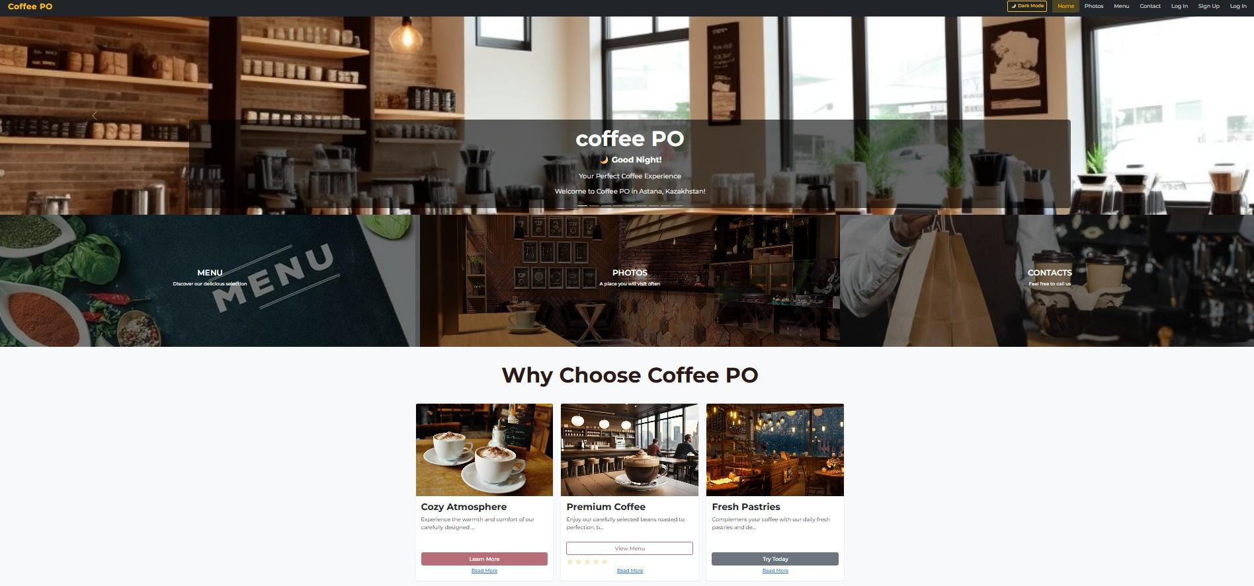

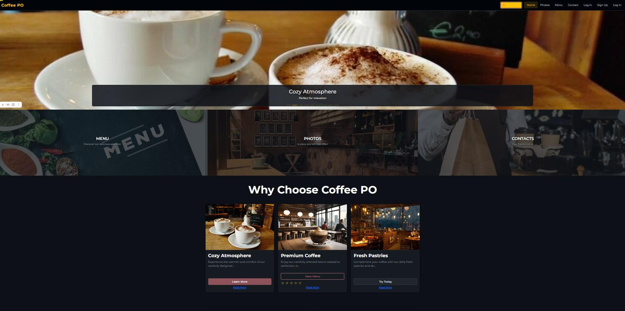



## Gallery Page (gallery.html)

**Purpose:** Visual showcase of the coffee shop's interior, products, and atmosphere.

**Key Features:**

 **Responsive Grid Layout** - 9 images in Bootstrap card grid

 **Search Functionality** - jQuery-powered search bar to filter images by title

 **Image Cards** - Each card includes image, title, description, and "View Details" button

 **Lazy Loading** - Images load progressively as user scrolls

 **Hover Effects** - Cards elevate and show description overlay on hover

**Layout Behavior:**

 Desktop (≥992px): 3 columns  Tablet (768-991px): 2 columns

 Mobile (<768px): 1 column (stacked)

**Images:**

 All images optimized for web (compressed without quality loss)  Aspect ratio maintained with object-fit: cover

* Alt text provided for accessibility
* **Screenshot:**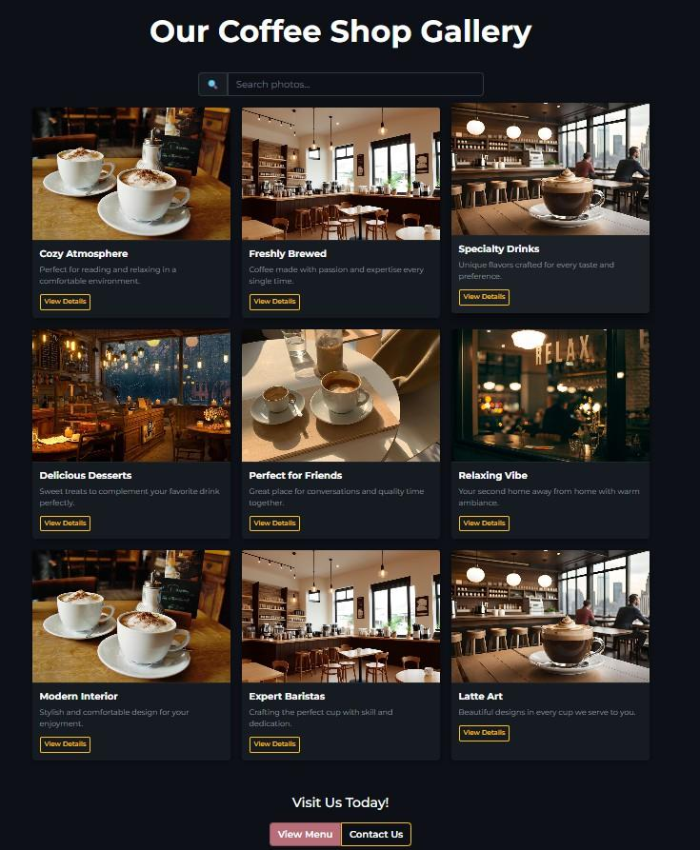

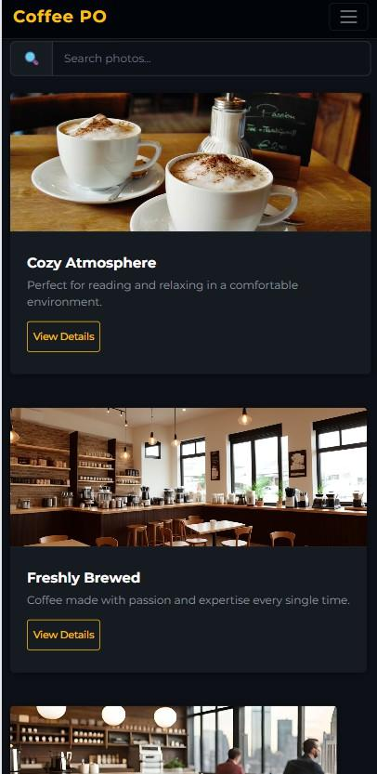

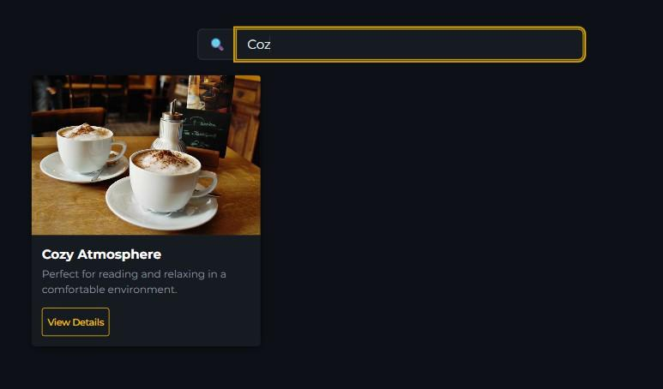



## Menu Page (menu.html)

**Purpose:** Display coffee and food offerings with prices and descriptions.

**Key Features:**

 **Menu Items Display** - 5 coffee items in horizontal cards  Latte (2500 ₸)

 Cappuccino (2300 ₸)

 Americano (1800 ₸)

 Mocha (2800 ₸)

 Espresso (1500 ₸)

 **Search Functionality** - Real-time search bar that filters menu items

 **Search Suggestions** - Dropdown with autocomplete suggestions  **Text Highlighting** - Search terms highlighted in yellow in results  **Rating System** - 5-star rating for each item with click interaction  **Special Offers Alert** - Bootstrap alert with subscription popup

 **Order Buttons** - Functional buttons that show confirmation and play sound

**Responsive Design:**

 Desktop: Side-by-side image and text  Tablet: Reduced image size

 Mobile: Stacked layout with centered content

**Interactive Elements:**

* Subscription popup modal (opens on "Get Special Offers" button)  Sound effects on button clicks using Web Audio API
*  Smooth animations on card hover

**Screenshot:**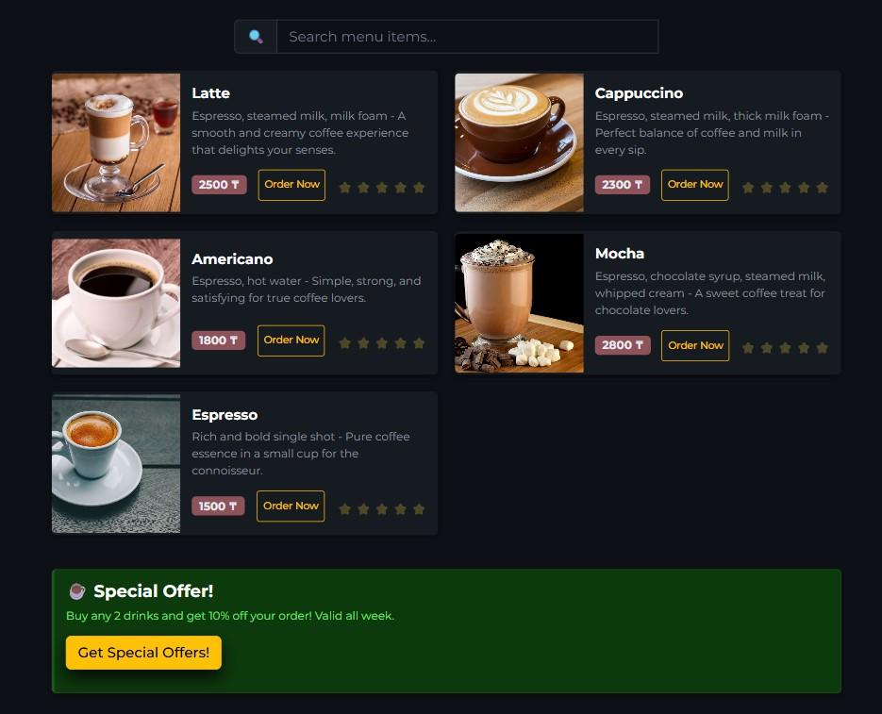

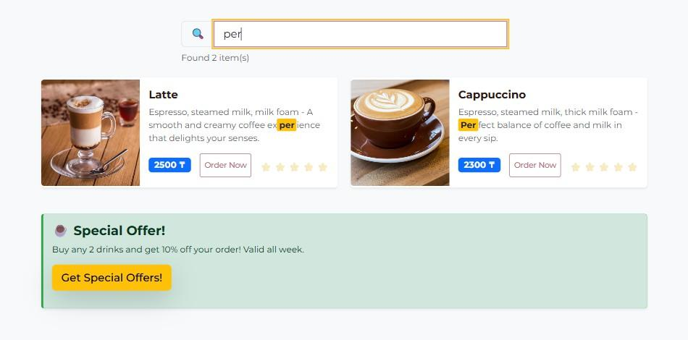

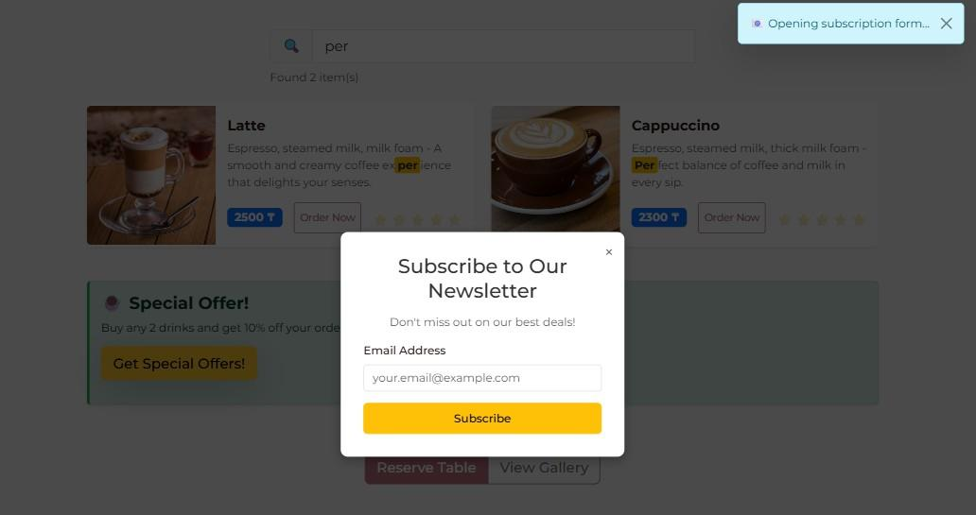

## Contact Page (contact.html)

**Purpose:** Allow users to send feedback and inquiries to the coffee shop.

**Key Features:**

 **Contact Form** with validation:

 Name (required, min 2 characters)  Email (required, valid format)

 Subject (dropdown: General Inquiry, Reservation, Feedback, Complaint, Other)  Message (required, min 10 characters)

 Newsletter checkbox

 Preferred contact method (radio: Email/Phone)

 **Form Validation** - Real-time validation with error messages

 **Loading State** - Spinner animation during form submission

 **Success Notification** - Toast notification on successful submission

 **Feedback Integration** - Forms submitted by logged-in users save to profile history

 **Contact Cards** - Phone and location information with copy buttons

**Form Processing:**

* + 1. Client-side validation checks all fields
    2. If valid, shows loading spinner
    3. Saves to user's feedback array in localStorage (if logged in)
    4. Displays success notification
    5. Resets form

**jQuery Enhancements:**

 Copy-to-clipboard buttons for phone numbers  Animated form submission with fade effects

 Notification system with auto-dismiss

**Screenshot: 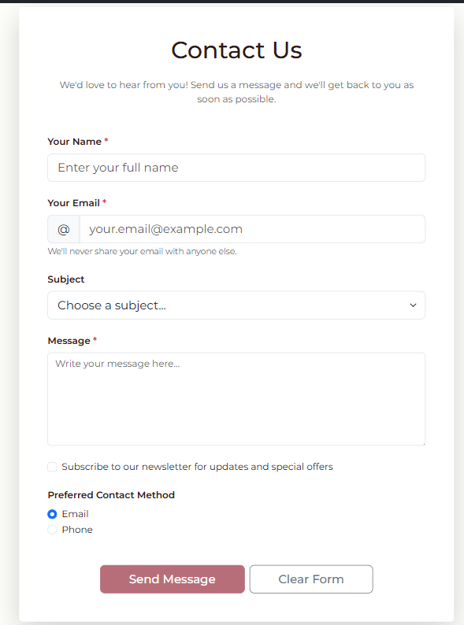**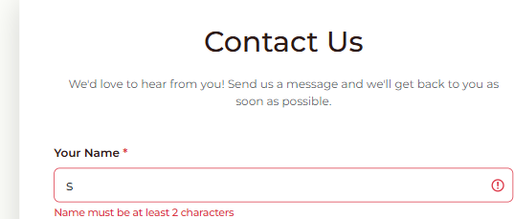

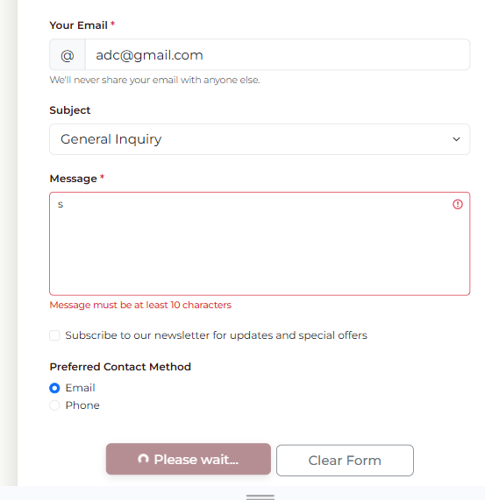

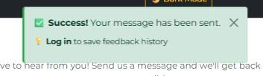

## Sign Up Page (signup.html)

**Purpose:** Allow new users to create an account.

**Key Features:**

 **Registration Form** with fields:

 Full Name (required, min 2 characters)  Email (required, unique, valid format)

 Password (required, min 8 chars, uppercase, lowercase, number)  Confirm Password (must match)

 Phone Number (optional, Kazakhstan format: +7 XXX XXX-XX-XX)  Terms & Conditions checkbox (required)

 **Password Toggle** - Eye icon to show/hide password

 **Real-time Validation** - Errors display immediately below fields

 **Password Strength Indicator** - Hint text explaining requirements

 **Email Uniqueness Check** - Prevents duplicate registrations

 **Success Message** - Confirmation before redirect to login

**Validation Rules:**

Email: /^[^\s@]+@[^\s@]+\.[^\s@]+$/;

Password: /^(?=.*[a-z])(?=.*[A-Z])(?=.*\d).{8,}$/;

Phone: /^\+?7\s?\(?\d{3}\)?\s?\d{3}[-\s]?\d{2}[-\s]?\d{2}$/;

**User Data Stored:**

{

id: Date.now(),

fullName: string, email: string,

password: string, // Note: In production, should be hashed phone: string,

createdAt: ISO date string, visits: 0,

feedback: []

}

**Screenshot:** 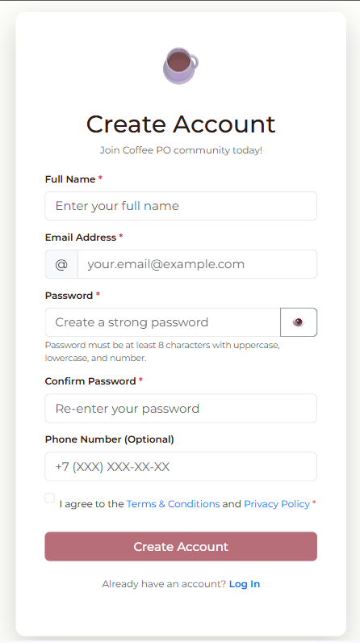



## Login Page (login.html)

**Purpose:** Authenticate existing users and grant access to profile.

**Key Features:**

 **Login Form** with fields:

 Email (required, valid format)  Password (required)

 Remember Me checkbox

 Forgot Password link (placeholder)

 **Authentication Logic**:

* + 1. Retrieves users array from localStorage
    2. Finds user with matching email and password
    3. Updates visit count
    4. Creates session in localStorage
    5. Redirects to profile page

 **Error Handling** - Clear error messages for invalid credentials

 **Loading State** - Spinner during authentication

 **Demo Credentials Info** - Helpful text for testing

**Session Data Stored:**

{

userId: number, email: string,

fullName: string,

loginTime: ISO date string

}

**Security Considerations:**

 Note: This is client-side authentication for demonstration  In production, would use backend authentication

 Passwords should be hashed (bcrypt)  Sessions should use JWT tokens

**Screenshot:** 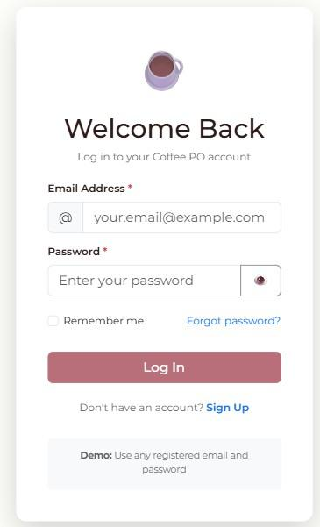



## Profile Page (profile.html)

**Purpose:** Display user information and feedback history.

**Key Features:**

1. **User Information Card:**

 Avatar circle with user initials  Full name and email

 Phone number

 Member since date

 Statistics: Feedback count, Visit count  Edit Profile button (opens modal)

 Logout button

1. **Feedback History Section:**

* Search bar to filter feedbac

 Subject filter dropdown

 List of all submitted feedback with:  Subject line

 Date and time

 Message content  Status badge

 "Clear All History" button

 Empty state message if no feedback

1. **Edit Profile Modal:**

 Update full name

 Update phone number

 Email cannot be changed (security)  Save/Cancel buttons

**Profile Features:**

 **Protected Route** - Redirects to login if not authenticated

 **Real-time Search** - Filter feedback by keyword

 **Subject Filter** - Filter by feedback category

 **Feedback Sorting** - Newest first by default

 **Data Persistence** - All changes saved to localStorage

**Data Flow:**

* 1. Page loads → Check authentication
  2. If authenticated → Load user data from localStorage
  3. Display profile info and feedback history
  4. User interactions → Update localStorage
  5. Changes reflect immediately**Screenshot:**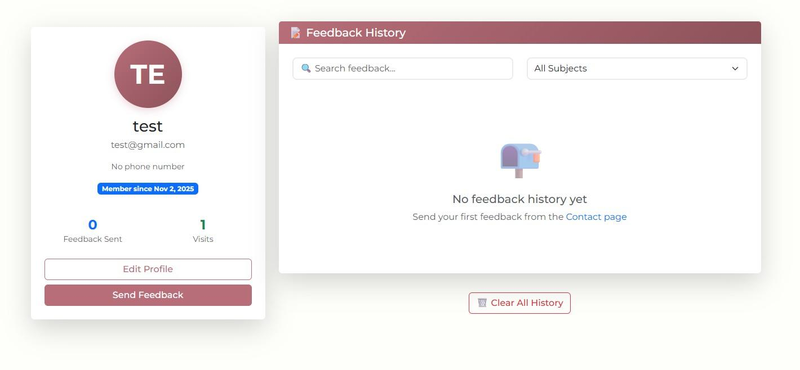

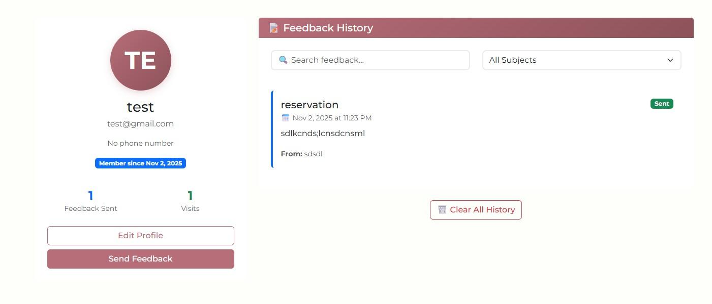



## Navigation System

**Dynamic Navigation:** The navigation bar adapts based on user authentication status:

**When NOT logged in:**

 Home  Photos  Menu

 Contact  **Sign Up ** **Log In**

**When logged in:**

 Home  Photos  Menu

 Contact

 **Profile**

 **Logout button**

**Implementation (auth.js):**

**Features:**

function updateNavigationLinks() {

const currentUser = JSON.parse(localStorage.getItem("currentUser") || "null");

if (currentUser) {

// Show Profile and Logout

} else {

// Show Sign Up and Log In

}

}

 Consistent across all pages  Dark mode toggle button

 Responsive collapse menu on mobile  Active page highlighting

 Smooth hover transitions

**Screenshot:** [Insert navigation screenshot - logged out state] [Insert navigation screenshot - logged in state] [Insert mobile navigation screenshot]



# Responsiveness Implementation

## Breakpoints Used:

 **Extra Small (< 576px):** Mobile phones

 **Small (576px - 767px):** Large phones, small tablets

 **Medium (768px - 991px):** Tablets

 **Large (992px - 1199px):** Small desktops

 **Extra Large (≥ 1200px):** Large desktops

## Responsive Techniques:

1. **Bootstrap Grid System:**

<div class="row">

<div class="col-lg-4 col-md-6 col-sm-12">

<!-- Content -->

</div>

</div>

1. **Custom Media Queries:**

@media (max-width: 767px) {

.carousel-img { height: 300px;

}

.card-img-top { height: 200px;

}

}

@media (min-width: 768px) and (max-width: 991px) {

.card-responsive-group > div { flex: 0 0 50%;

}

}

@media (min-width: 992px) {

.card-responsive-group > div { flex: 0 0 33.333%;

}

}

1. **Flexbox & CSS Grid:**

.promo-grid {

display: flex; gap: 0;

}

@media (max-width: 768px) {

.promo-grid {

flex-direction: column;

}

}

1. **Responsive Images:**

img {

max-width: 100%; height: auto;

}

.carousel-img {

object-fit: cover;

}

1. **Responsive Typography:**

.responsive-title {

font-size: clamp(1.5rem, 4vw, 3rem);

}

Testing Results:

|  |  |  |  |  |  |
| --- | --- | --- | --- | --- | --- |
| **Device** | **Screen Size** | **Layout** | **Navigation** | **Forms** | **Images** |
| iPhone SE | 375x667 | ✅ | ✅ | ✅ | ✅ |
| iPhone 12 Pro | 390x844 | ✅ | ✅ | ✅ | ✅ |
| iPad | 768x1024 | ✅ | ✅ | ✅ | ✅ |

|  |  |  |  |  |  |
| --- | --- | --- | --- | --- | --- |
| **Device** | **Screen Size** | **Layout** | **Navigation** | **Forms** | **Images** |
| iPad Pro | 1024x1366 | ✅ | ✅ | ✅ | ✅ |
| Desktop HD | 1366x768 | ✅ | ✅ | ✅ | ✅ |
| Desktop FHD  **Screenshot:** | 1920x1080 | ✅ | ✅ | ✅ | ✅ |

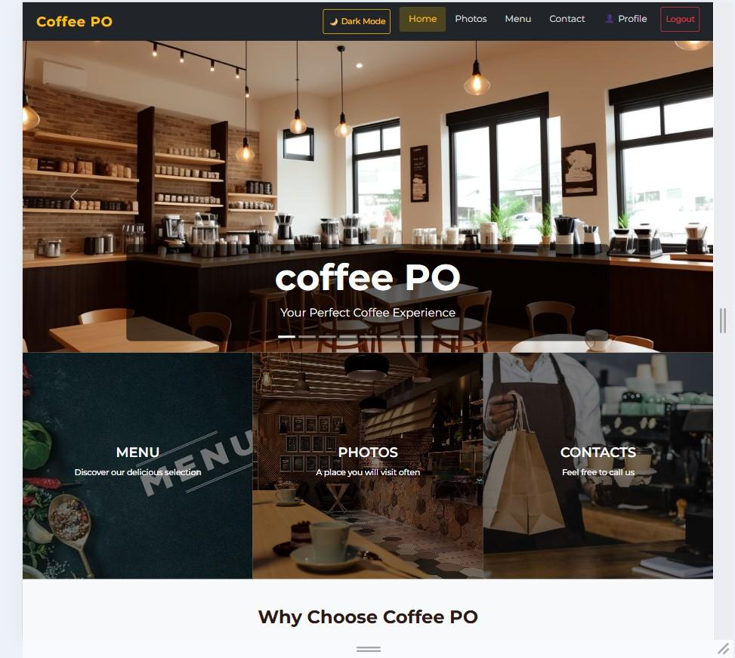

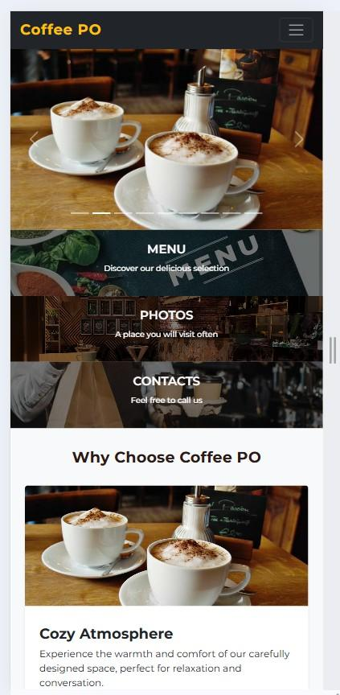



# Light and Dark Modes

## Implementation:

**Toggle Button:**

 Located in navigation bar on all pages  Shows "🌙 Dark Mode" in light mode  Shows "☀ Light Mode" in dark mode  Click toggles between modes

**LocalStorage Persistence:**

// Save preference

localStorage.setItem("colorMode", "dark");

// Load on page load

const savedMode = localStorage.getItem("colorMode"); if (savedMode === "dark") {

document.body.classList.add("dark-mode");

}

**Color Schemes:**

**Light Mode:**

 Background: #fefffb (off-white)  Text: #333 (dark gray)

 Primary: #b76e79 (brown-pink)  Cards: #ffffff (white)

 Contrast Ratio: 12.63:1 ✅ WCAG AA

**Dark Mode:**

 Background: #0d1117 (GitHub dark)  Text: #e6edf3 (light gray)

 Primary: #8d525a (muted brown)  Cards: #161b22 (dark gray)

 Contrast Ratio: 11.91:1 ✅ WCAG AA

**CSS Implementation:**

/* Light Mode (default) */ body {

background-color: #fefffb; color: #333;

}

/* Dark Mode */ body.dark-mode {

background-color: #0d1117; color: #e6edf3;

}

body.dark-mode .card {

background-color: #161b22; border-color: #21262d;

}

body.dark-mode .navbar-dark { background-color: #010409;

}

**Features:**

 ✅ Consistent across all pages

 ✅ Persists after page refresh

 ✅ Smooth transitions between modes

 ✅ All elements properly styled

 ✅ WCAG AA compliant contrast

 ✅ Readable in both modes



# JavaScript Functionality

## Authentication Simulation

**Sign Up Process:**

* + 1. User fills registration form
    2. Validation checks all fields
    3. Check if email already exists
    4. Create user object
    5. Store in localStorage users array
    6. Show success message
    7. Redirect to login page

**Login Process:**

1. User enters credentials
2. Validate email format
3. Find user in localStorage
4. Compare passwords
5. Update visit count
6. Create session
7. Redirect to profile

**Profile Access:**

1. Check for currentUser in localStorage
2. If not found → redirect to login
3. Load user data
4. Display profile information
5. Load feedback history**Code Example:**



// Sign Up

const user = {

id: Date.now(),

fullName: fullName, email: email,

password: password,

createdAt: new Date().toISOString(), visits: 0,

feedback: [],

};

const users = JSON.parse(localStorage.getItem("users") || "[]"); users.push(user);

localStorage.setItem("users", JSON.stringify(users));

// Login

const users = JSON.parse(localStorage.getItem("users") || "[]");

const user = users.find((u) => u.email === email && u.password === password);

if (user) {

const sessionData = { userId: user.id,

email: user.email,

fullName: user.fullName,

loginTime: new Date().toISOString(),

};

localStorage.setItem("currentUser", JSON.stringify(sessionData));

}

## Form Validation

**Email Validation:**

function validateEmail(email) {

const regex = /^[^\s@]+@[^\s@]+\.[^\s@]+$/; return regex.test(email);

}

**Password Validation:**

function validatePassword(password) {

// At least 8 characters, 1 uppercase, 1 lowercase, 1 number const regex = /^(?=.*[a-z])(?=.*[A-Z])(?=.*\d).{8,}$/;

return regex.test(password);

}

**Phone Validation (Kazakhstan):**

function validatePhone(phone) {

if (!phone) return true; // Optional

const regex = /^\+?7\s?\(?\d{3}\)?\s?\d{3}[-\s]?\d{2}[-\s]?\d{2}$/; return regex.test(phone);

}

**Error Display:**

function showFieldError(fieldId, message) {

const field = document.getElementById(fieldId); const errorDiv = document.createElement("div"); errorDiv.className = "invalid-feedback d-block"; errorDiv.textContent = message;

field.classList.add("is-invalid");

field.parentElement.appendChild(errorDiv);

}

**Forms with Validation:**

 Sign Up Form: 6 fields validated  Login Form: 2 fields validated

 Contact Form: 4 fields validated

 Edit Profile Form: 2 fields validated



## Search and Filtering

**Menu Search:**

$("#menuSearch").on("keyup", function () {

const searchTerm = $(this).val().toLowerCase(); let visibleCount = 0;

$(".col-lg-6.col-md-12").filter(function () {

const cardText = $(this).text().toLowerCase();

const matches = cardText.indexOf(searchTerm) > -1;

$(this).toggle(matches);

if (matches) visibleCount++; return true;

});

$("#searchResults").text(`Found ${visibleCount} item(s)`);

});

**Gallery Search:**

$("#gallerySearch").on("keyup", function () {

const searchTerm = $(this).val().toLowerCase();

$(".col-lg-4.col-md-6.col-sm-12").filter(function () { const cardText = $(this).text().toLowerCase();

$(this).toggle(cardText.indexOf(searchTerm) > -1);

});

});

**Profile Feedback Filter:**

function filterFeedback(userId) {

const searchTerm = $("#searchFeedback").val().toLowerCase(); const subjectFilter = $("#filterSubject").val();

let filteredFeedback = user.feedback;

// Filter by subject if (subjectFilter) {

filteredFeedback = filteredFeedback.filter(

(f) => f.subject === subjectFilter

);

}

// Filter by search term if (searchTerm) {

filteredFeedback = filteredFeedback.filter(

(f) =>

f.message.toLowerCase().includes(searchTerm) || f.subject.toLowerCase().includes(searchTerm)

);

}

displayFeedbackHistory(filteredFeedback);

}

**Search Suggestions:**

const menuSuggestions = [ "Latte",

"Cappuccino", "Americano", "Mocha",

"Espresso",

];

$("#menuSearch").on("input", function () {

const searchTerm = $(this).val().toLowerCase(); const matches = menuSuggestions.filter((item) =>

item.toLowerCase().includes(searchTerm)

);

// Display suggestions dropdown

});



## Dynamic Content

**Animated Counters:**

$(".counter").each(function () { const $this = $(this);

const target = parseInt($this.attr("data-target"));

$({ counter: 0 }).animate(

{ counter: target },

{

duration: 2000, easing: "swing",

step: function () {

$this.text(Math.ceil(this.counter) + "+");

},

}

);

});

**Lazy Loading Images:**

function lazyLoadImages() {

$(".lazy-image").each(function () { const $img = $(this);

const imgTop = $img.offset().top;

const viewportBottom = $(window).scrollTop() + $(window).height();

if (imgTop < viewportBottom + 200) {

const dataSrc = $img.attr("data-src");

$img

.attr("src", dataSrc)

.removeClass("lazy-image")

.addClass("lazy-loaded");

}

});

}

$(window).on("scroll", lazyLoadImages);

**Scroll Progress Bar:**



$(window).on("scroll", function () {

const scrollTop = $(window).scrollTop();

const docHeight = $(document).height() - $(window).height(); const scrollPercent = (scrollTop / docHeight) * 100;

$("#scrollProgress").css("width", scrollPercent + "%");

});

# Animated Buttons & UI Effects

## Hover Effects:

**Button Transitions:**

.btn {

transition: all 0.3s ease;

}

.btn:hover {

transform: translateY(-2px);

box-shadow: 0 4px 12px rgba(0, 0, 0, 0.15);

}

**Card Hover:**

.card {

transition: all 0.3s ease;

}

.card:hover {

transform: translateY(-10px);

box-shadow: 0 12px 24px rgba(0, 0, 0, 0.15);

}

**Navigation Links:**

.navbar-dark .navbar-nav .nav-link { transition: all 0.3s ease;

}

.navbar-dark .navbar-nav .nav-link:hover { color: #ffc107;

background-color: rgba(255, 193, 7, 0.1);

transform: translateY(-2px);

}

## Click Animations:

**Button Pulse:**

@keyframes pulse { 0% {

transform: scale(1);

}

50% {

transform: scale(1.1);

}

100% {

transform: scale(1);

}

}

.btn:active {

animation: pulse 0.5s ease;

}

**Form Validation Shake:**

@keyframes shake { 0%,

100% {

transform: translateX(0);

}

25% {

transform: translateX(-10px);

}

75% {

transform: translateX(10px);

}

}

.is-invalid {

animation: shake 0.5s ease;

}

## Scroll Animations:

**Fade In on Scroll:**

const observer = new IntersectionObserver( function (entries) {

entries.forEach((entry) => { if (entry.isIntersecting) {

entry.target.style.opacity = "0";

entry.target.style.transform = "translateY(30px)";

setTimeout(() => {

entry.target.style.transition = "all 0.6s ease"; entry.target.style.opacity = "1";

entry.target.style.transform = "translateY(0)";

}, 100);

}

});

},

{ threshold: 0.1 }

);

document.querySelectorAll(".card").forEach((card) => { observer.observe(card);

});

## Loading States:

**Spinner Animation:**

<button class="btn btn-primary">

<span class="btn-text">Submit</span>

<span class="spinner-border spinner-border-sm d-none"></span>

</button>

// Show loading

submitBtn.querySelector(".btn-text").classList.add("d-none");

submitBtn.querySelector(".spinner-border").classList.remove("d-none"); submitBtn.disabled = true;

Toast Notifications:

function showNotification(message, type) { const notification = $(`

<div class="alert alert-${type} alert-dismissible fade show">

${message}

<button type="button" class="btn-close"></button>

</div>

`);

$("#notificationContainer").append(notification);

setTimeout(() => {

notification.fadeOut(500, function () {

$(this).remove();

});

}, 4000);

}



# Accessibility & Navigation

## Navigation Features:

✅ **Consistent Navigation Bar** on all 7 pages ✅ **Active Page Highlighting** shows current location ✅

**Responsive Collapse Menu** for mobile devices ✅ **Keyboard Navigation** - Tab through all links ✅ **Skip to Main Content** link (for screen readers)

## Accessibility Compliance:

1. **Semantic HTML:**

<header>

<nav aria-label="Main navigation">

<ul>

<li><a href="index.html">Home</a></li>

</ul>

</nav>

</header>

<main>

<section aria-labelledby="menu-heading">

<h1 id="menu-heading">Our Menu</h1>

</section>

</main>

<footer>

<address>Contact information</address>

</footer>

1. **Alt Text for Images:**

<img src="img/latte.jpg" alt="Creamy latte with milk foam art" />

<img src="img/1.jpeg" alt="Cozy coffee shop interior" />

1. **Heading Structure:**

<h1>Coffee PO</h1>

<h2>Our Menu</h2>

<h3>Hot Drinks</h3>

<h3>Cold Drinks</h3>

<h2>About Us</h2>

1. **ARIA Labels:**

<button aria-label="Toggle dark mode">🌙 Dark Mode</button>

<input type="search" aria-label="Search menu items" />

<nav aria-label="Main navigation"></nav>

1. **Keyboard Navigation:**

/* Focus indicators */ a:focus,

button:focus, input:focus {

outline: 2px solid #ffc107; outline-offset: 2px;

}

// Arrow key navigation

document.addEventListener("keydown", function (event) { if (event.key === "ArrowRight") {

// Navigate to next link

}

});

This code demonstrates accessibility best practices to make the site usable for everyone, including users with disabilities.

**Key Points**

Consistent Navigation across all pages Mobile-friendly menu + active link highlight Keyboard-friendly (Tab

navigation + visible focus) Skip to Content link for screen readers Semantic HTML (header, nav, main, footer) Proper alt text for all images Correct heading hierarchy (h1 → h2 → h3) ARIA labels for screen readers Optional arrow-key navigation logic in JS

# ✅ Conclusion

Our coffee restaurant website is a fully functional, responsive, and user-friendly web application. We

implemented a clean UI and smooth navigation across all pages, ensuring an intuitive user experience on both desktop and mobile devices.

Using HTML5, CSS3, JavaScript, and Bootstrap, we built modern and aesthetically pleasing pages with

interactive features like menus, forms, and navigation effects. Accessibility principles and semantic structure were applied to make the site usable for all visitors.

In the end, the project successfully demonstrates a real-world restaurant website that reflects professionalism, attention to detail, and practical front-end development skills.